Report on REFOG-KEYLOGGER :

1. Install Refog-keylogger downloaded from [*https://www.refog.com/*](https://www.refog.com/)
2. Create an account on REFOG.
3. Click “ctrl+shift+alt+k” or run the command “runrefog” to start the app.

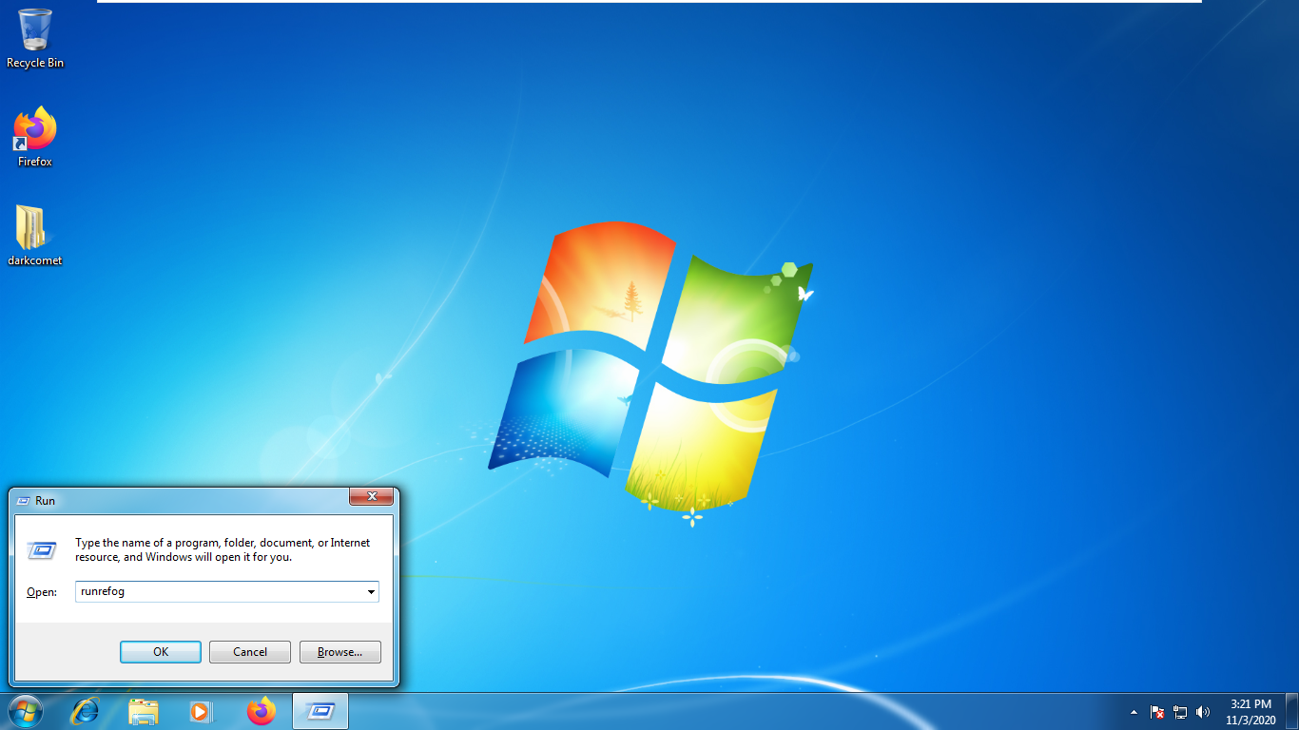

1. As soon as application starts, it shows all the users of that particular application.

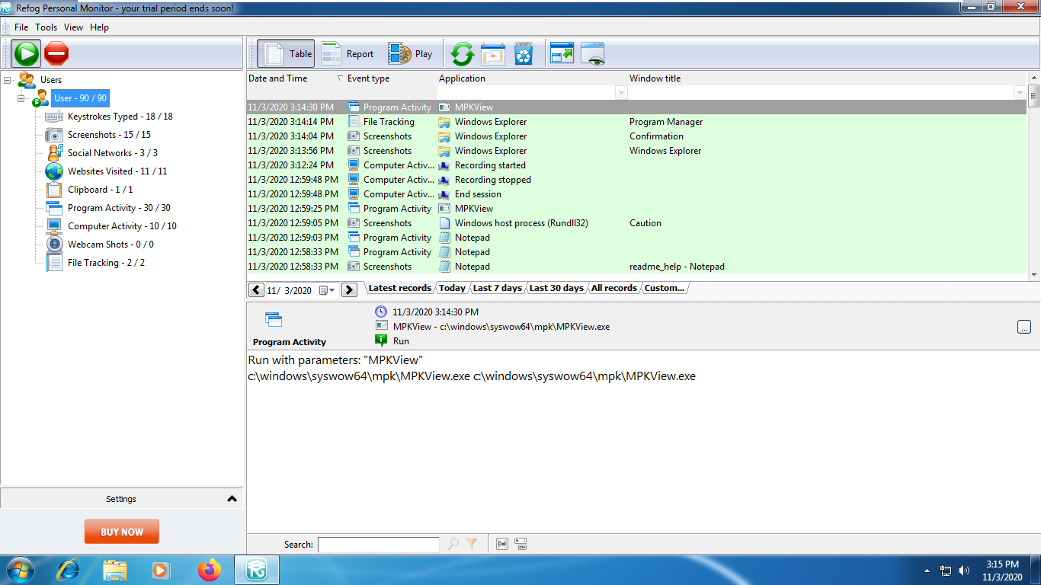

1. The first option of refog is “keystrokes-typed” which saves the every key that was typed from the time it was installed.

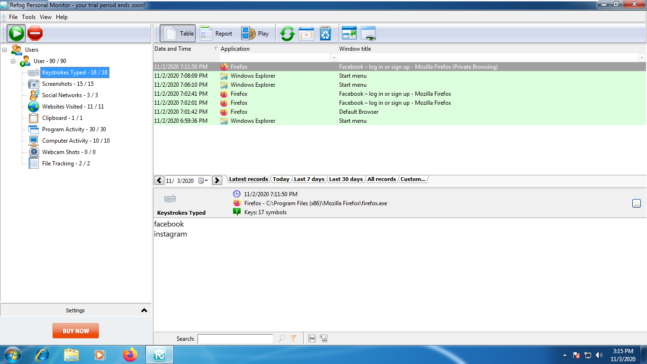

1. Next option is “screenshots” which saves every screenshot of the activity which happens on your PC.

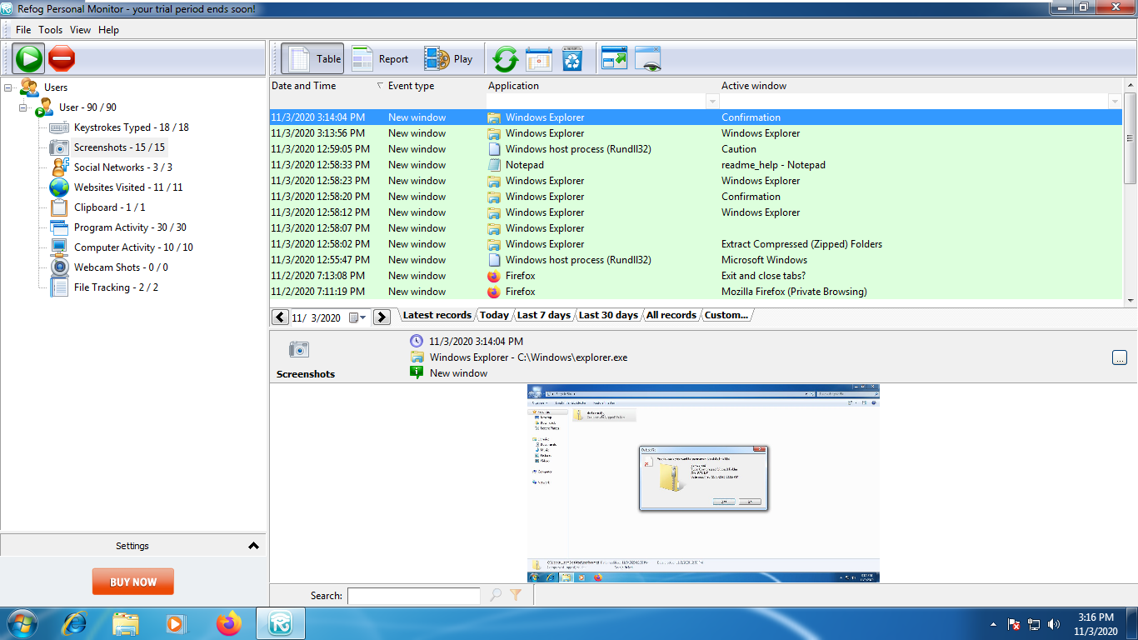

1. Social Networks : It registers all the social network sites the host has been accessing.

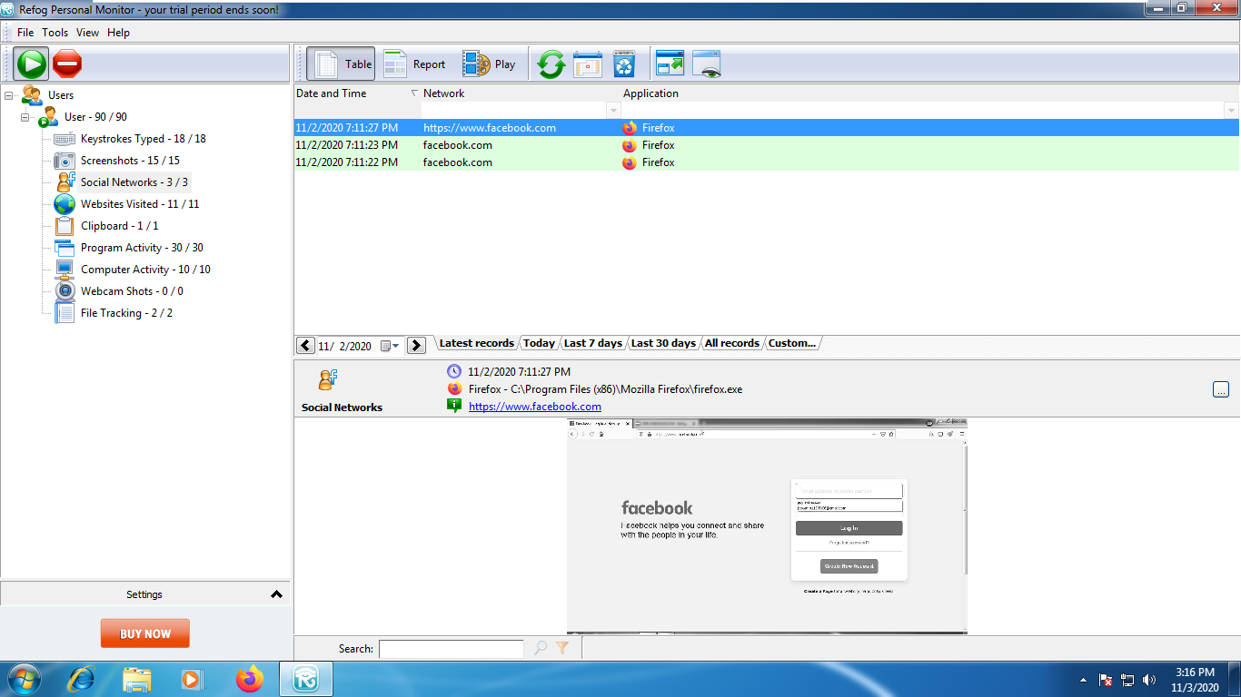

1. “Websites Visited”, this option shows all the websites the host has been accessing from the time of installation of keylogger.

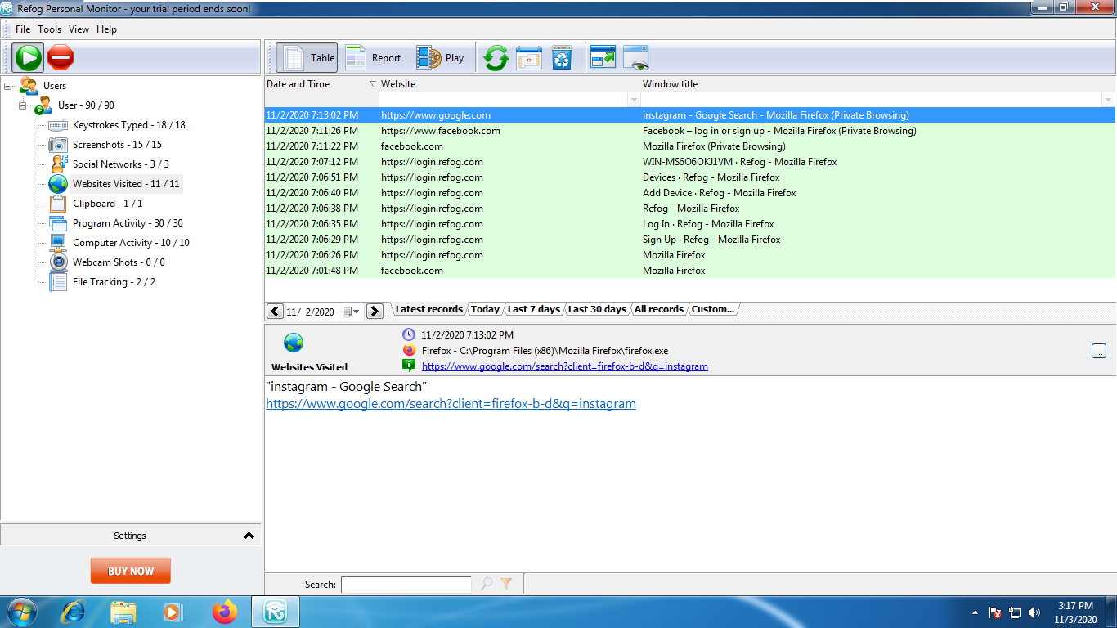

1. “Clipboard” saves the information which has been saved to the clipboard or information which has been copied.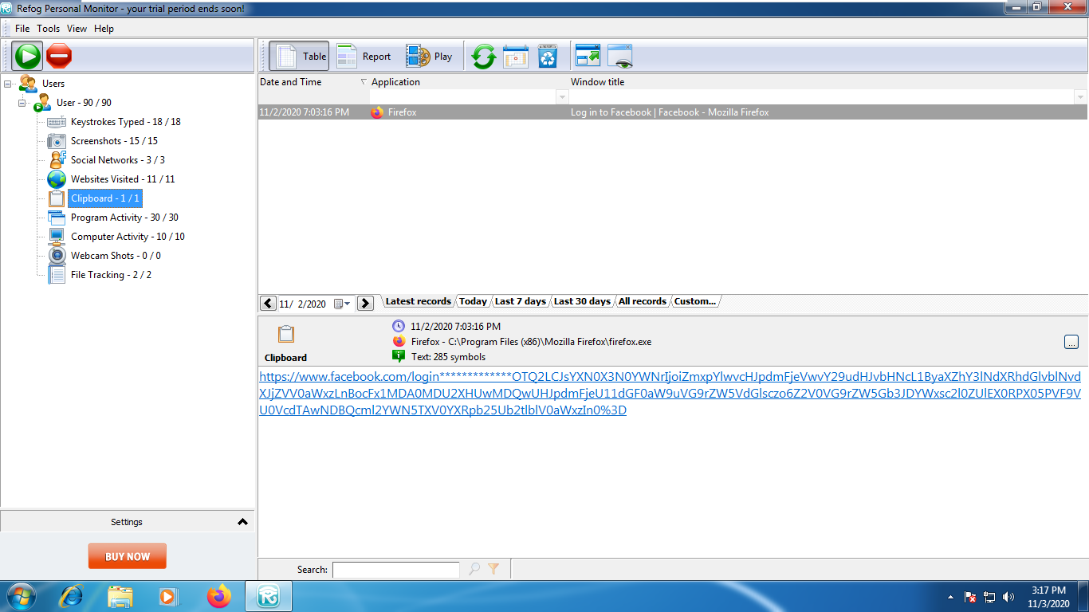
2. “Program Activity” saves all the programs which are running on the PC with or without the host’s knowledge.

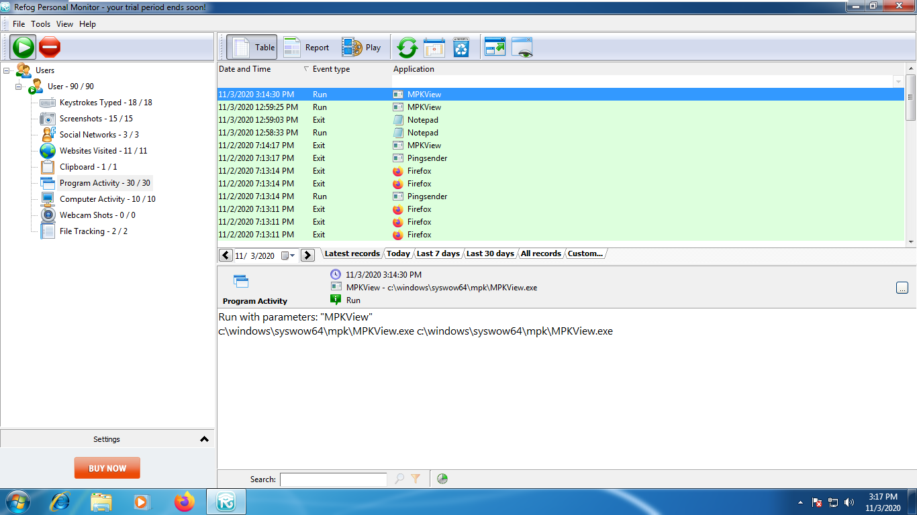

1. “Computer Activity” shows the activities of refog keylogger like when it is started and ended the session, recording beginning and ending.

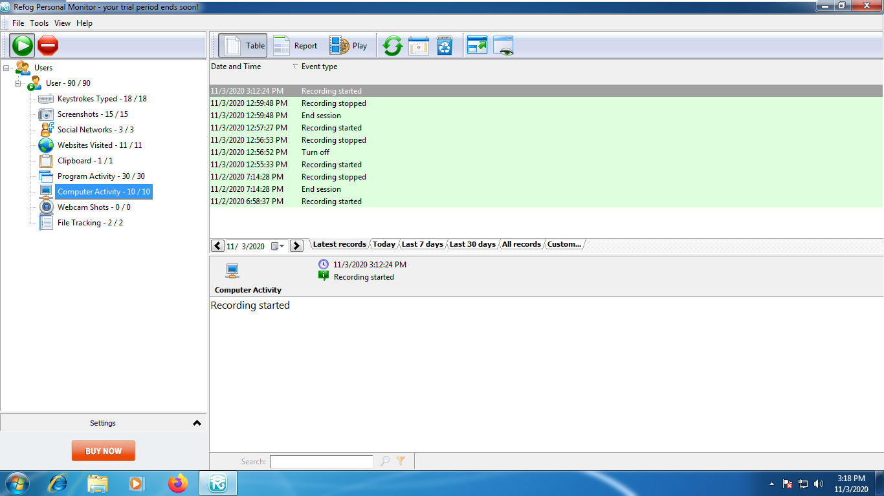

1. “Webcam shots” saves the photos that has been captured by using webcam while the using the host PC.

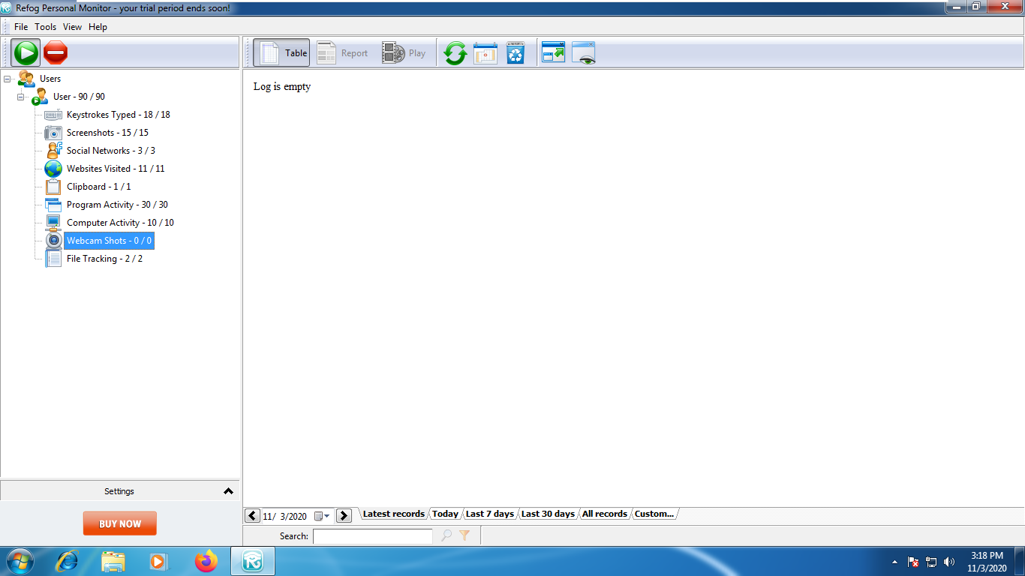

1. “File Tracking” saves the logs of date and time when the files are altered or opened.

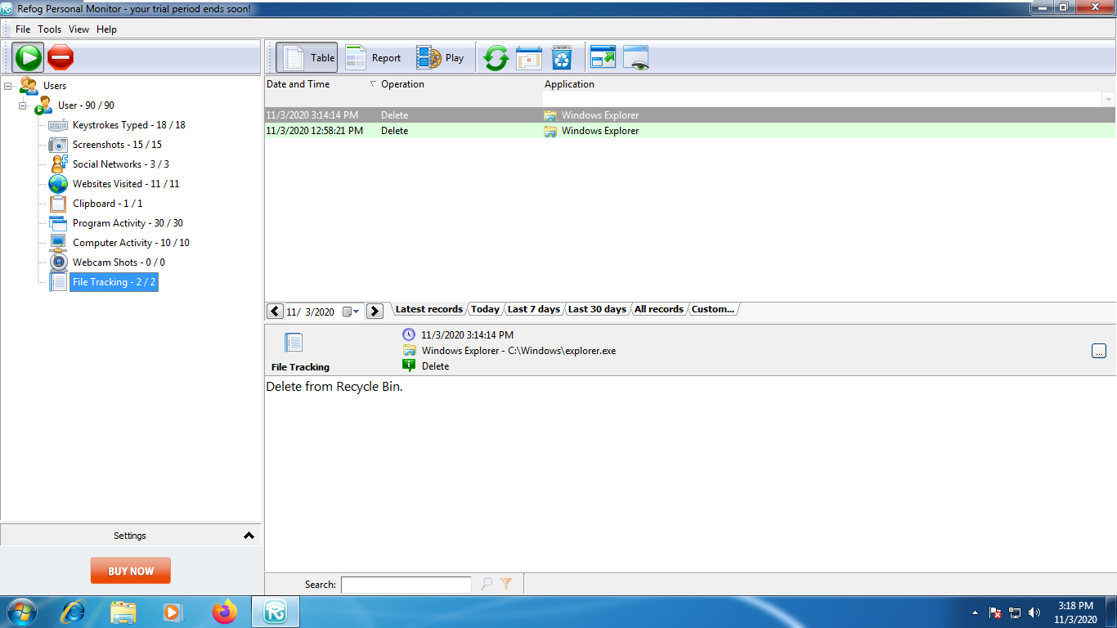

1. Refog keylogger saves the data which was accessed on internet even through private browsing.

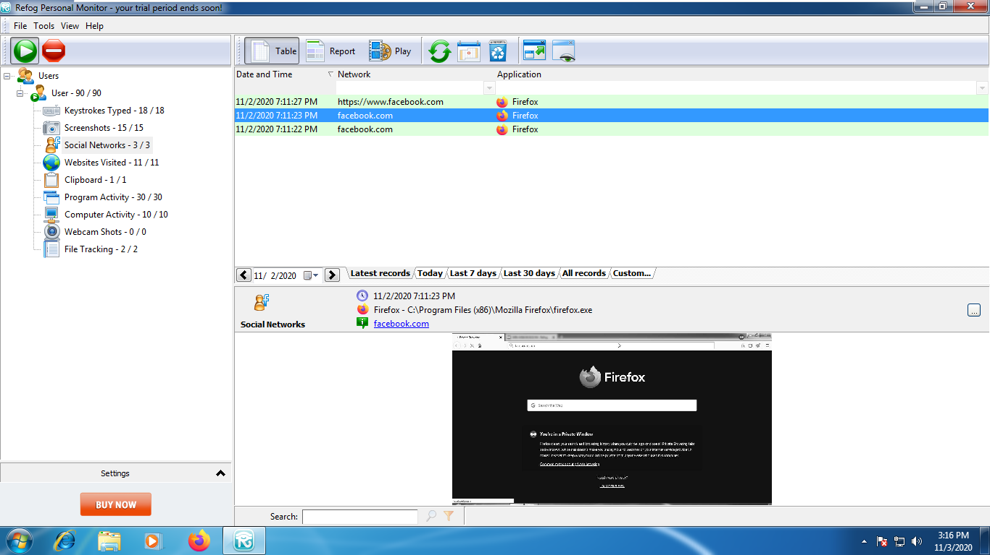

1. Refog cannot be found neither through search bar nor through control panel.

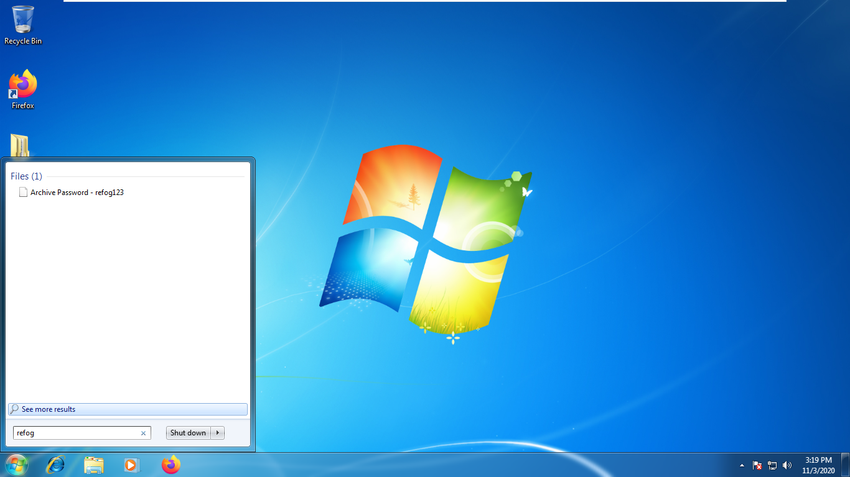

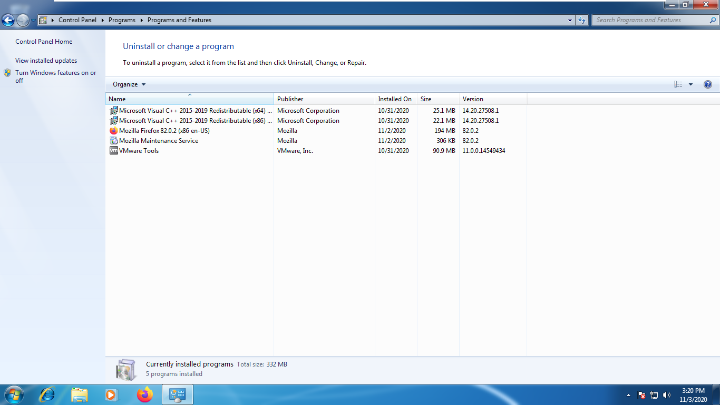

1. Refog has a feature to activate it through online account so that the user can monitor through online account.

